Case Study: 1
Title: Development of a College Department Webpage Using HTML, CSS, and JavaScript
Software/Tools Required: VSC, HTML, CSS, JavaScript
Case Study program code:
INDEX:
<!DOCTYPE html>
<html lang="en">
<head>
<meta charset="UTF-8">
<meta name="viewport" content="width=device-width, initial-scale=1.0">
<title>SIT Nagpur - Computer Science Department</title>

<script>
window.onload = function () {
alert("Welcome to SIT Nagpur");
};
</script>

<style>
*{
margin:0;
padding:0;
box-sizing:border-box;
font-family:Arial, Helvetica, sans-serif;
}

body{
background:#f4f7fb;
color:#333;
}

header{
background:#E10600;
color:white;
padding:25px;
text-align:center;
}

nav{
background:#B30000;;
text-align:center;
padding:12px;
}

nav a{
color:white;
text-decoration:none;
margin:0 20px;
font-weight:bold;
}

.container{
width:85%;
margin:30px auto;
}

.card{
position:relative;
background:white;
padding:40px;
border-radius:15px;
border:3px solid #D4AF37;
box-shadow:0 10px 25px rgba(0,0,0,.15);
overflow:hidden;
}

h2{
color:#E10600;
margin-bottom:15px;
}

p{
line-height:1.7;
margin-bottom:15px;
}

.btn{
display:inline-block;
padding:12px 22px;
background:#E10600;
color:white;
text-decoration:none;
border-radius:6px;
transition:.3s;
}

.btn:hover{
background:#bf0312;
}

footer{
background:#a40303;
color:white;
text-align:center;
padding:15px;
margin-top:40px;
}

.gold-flourish{
position:absolute;
color:#D4AF37;
font-size:34px;
font-weight:bold;
font-family:"Times New Roman", serif;
}

.tl{
top:10px;
left:12px;
}

.tr{
top:10px;
right:12px;
transform:rotate(90deg);
}

.bl{
bottom:10px;
left:12px;
transform:rotate(-90deg);
}

.br{
bottom:10px;
right:12px;
transform:rotate(180deg);
}

.logo{
width:120px;
height:auto;
}

</style>
</head>

<body>

<header>
<div class="header-content">

<img src="https://yt3.googleusercontent.com/HmzxLu3bNe-i-YtaNxIzXK-mdQouqAjhT-8tQENdpgyLyCy4ddXzhmhZIsLw655TjNpMdAm7mOA=s900-c-k-c0x00ffffff-no-rj" alt="SIT Logo" class="logo">

<div class="title">
<h1>Symbiosis Institute of Technology, Nagpur</h1>
<p>Department of Computer Science & Engineering</p>
</div>

</div>
</header>

<nav>
<a href="index.html">Home</a>
<a href="student.html">Student Information</a>
<a href="programme.html">Programme structure</a>

</nav>

<div class="container">
<div class="card">
<div class="corner top-left"></div>
<div class="corner top-right"></div>
<div class="corner bottom-left"></div>
<div class="corner bottom-right"></div>
<div class="gold-flourish tl">❈</div>
<div class="gold-flourish tr">❈</div>
<div class="gold-flourish bl">❈</div>
<div class="gold-flourish br">❈</div>
<h2>About the Department</h2>

<p>
The Department of Computer Science & Engineering at
SIT Nagpur is committed to delivering quality education
through modern laboratories, experienced faculty, and
industry-oriented learning practices.
</p>

<p>
The department emphasizes software development, data science,
artificial intelligence, cybersecurity, cloud computing, and
research activities that prepare students for successful careers.
</p>

</div>
</div>

<footer>
&copy; 2026 SIT Nagpur | Department of Computer Science & Engineering
</footer>

</body>
</html>
PROGRAME.HTML:
<!DOCTYPE html>
<html lang="en">
<head>
<meta charset="UTF-8">
<meta name="viewport" content="width=device-width, initial-scale=1.0">
<title>Programme Structure - SIT Nagpur</title>

<style>
*{
margin:0;
padding:0;
box-sizing:border-box;
font-family:Arial, Helvetica, sans-serif;
}

body{
background:#faf7f2;
color:#333;
}

/* Header */

header{
background:#E10600;
color:white;
text-align:center;
padding:28px;
border-bottom:6px solid #D4AF37;
}

header h1{
font-size:2.5rem;
}

header p{
margin-top:8px;
font-size:1.1rem;
}

/* Navigation */

nav{
background:#B30000;
text-align:center;
padding:14px;
}

nav a{
color:white;
text-decoration:none;
margin:0 20px;
font-weight:bold;
transition:0.3s;
}

nav a:hover{
color:#FFD700;
}

/* Container */

.container{
width:90%;
margin:40px auto;
}

.card{
background:white;
padding:30px;
border-radius:12px;
border:3px solid #D4AF37;
box-shadow:0 8px 20px rgba(0,0,0,0.12);
}

h2{
color:#E10600;
margin-bottom:10px;
}

h2::after{
content:"";
display:block;
width:110px;
height:4px;
background:#D4AF37;
margin-top:8px;
border-radius:10px;
}

p{
margin:20px 0;
line-height:1.8;
}

table{
width:100%;
border-collapse:collapse;
margin-top:25px;
}

th{
background:#E10600;
color:white;
padding:14px;
}

td{
padding:14px;
text-align:center;
border:1px solid #ddd;
}

tr:nth-child(even){
background:#f8f8f8;
}

tr:hover{
background:#fff8e6;
}

footer{
margin-top:45px;
background:#A40303;
color:white;
text-align:center;
padding:18px;
border-top:5px solid #D4AF37;
}

</style>
</head>

<body>

<header>
<h1>Symbiosis Institute of Technology, Nagpur</h1>
<p>Department of Computer Science & Engineering</p>
</header>

<nav>
<a href="index.html">Home</a>
<a href="student.html">Student Information</a>
<a href="program.html">Programme Structure</a>
</nav>

<div class="container">

<div class="card">

<h2>Programme Structure</h2>

<p>
The Bachelor of Technology (B.Tech.) in Computer Science & Engineering is designed to provide students with a strong foundation in computing principles, programming, software development, data science, artificial intelligence, networking, cybersecurity, and emerging technologies. The curriculum combines theoretical knowledge with laboratory practice, industry-oriented projects, and skill development.
</p>

<table>

<tr>
<th>Semester</th>
<th>Major Subjects</th>
<th>Credits</th>
</tr>

<tr>
<td>I</td>
<td>Programming Fundamentals, Mathematics-I, Physics, Engineering Graphics</td>
<td>22</td>
</tr>

<tr>
<td>II</td>
<td>Data Structures, Mathematics-II, Digital Electronics, Environmental Studies</td>
<td>22</td>
</tr>

<tr>
<td>III</td>
<td>Object Oriented Programming, Database Management System, Operating Systems</td>
<td>23</td>
</tr>

<tr>
<td>IV</td>
<td>Computer Networks, Design & Analysis of Algorithms, Software Engineering</td>
<td>23</td>
</tr>

<tr>
<td>V</td>
<td>Artificial Intelligence, Web Technologies, Data Science</td>
<td>22</td>
</tr>

<tr>
<td>VI</td>
<td>Cloud Computing, Cyber Security, Machine Learning</td>
<td>22</td>
</tr>

<tr>
<td>VII</td>
<td>Major Project - I, Professional Electives, Internship</td>
<td>20</td>
</tr>

<tr>
<td>VIII</td>
<td>Major Project - II, Seminar, Professional Ethics</td>
<td>18</td>
</tr>

</table>

</div>

</div>

<footer>
&copy; 2026 SIT Nagpur | Department of Computer Science & Engineering
</footer>

</body>
</html>
STUDENT.HTML:
<!DOCTYPE html>
<html lang="en">
<head>
<meta charset="UTF-8">
<meta name="viewport" content="width=device-width, initial-scale=1.0">
<title>Student Information</title>

<style>
*{
margin:0;
padding:0;
box-sizing:border-box;
font-family:Arial, Helvetica, sans-serif;
}

body{
background:#eef2f7;
}

header{
background:#c80505;
color:white;
text-align:center;
padding:20px;
background:#E10600;
color:white;
padding:25px;
text-align:center;
border-bottom:6px solid #D4AF37;
}

.container{
width:90%;
margin:35px auto;
}

table{
width:100%;
border-collapse:collapse;
background:white;
box-shadow:0 4px 10px rgba(0,0,0,0.1);
}

th{
background:#a70000;
color:white;
padding:14px;
}

td{
padding:12px;
text-align:center;
border:1px solid #ddd;
}

tr:nth-child(even){
background:#f8f8f8;
}

.back{
display:inline-block;
margin-top:20px;
text-decoration:none;
background:#c40707;
color:white;
padding:10px 20px;
border-radius:5px;
}

.back:hover{
background:#d90505;
}
</style>
</head>

<body>

<header>
<h1>Student Information</h1>
</header>

<div class="container">

<table>

<tr>
<th>PRN.</th>
<th>Name</th>
<th>Program</th>
<th>Year</th>
<th>Email</th>
</tr>

<tr>
<td>24070521145</td>
<td>Ayushi Ray</td>
<td>B.Tech CSE</td>
<td>Third Year</td>
<td>ayushi@example.com</td>
</tr>

</table>

<a href="index.html" class="back">← Back to Department Page</a>

</div>

</body>
</html>
OUTPUT SCREENSHOT:
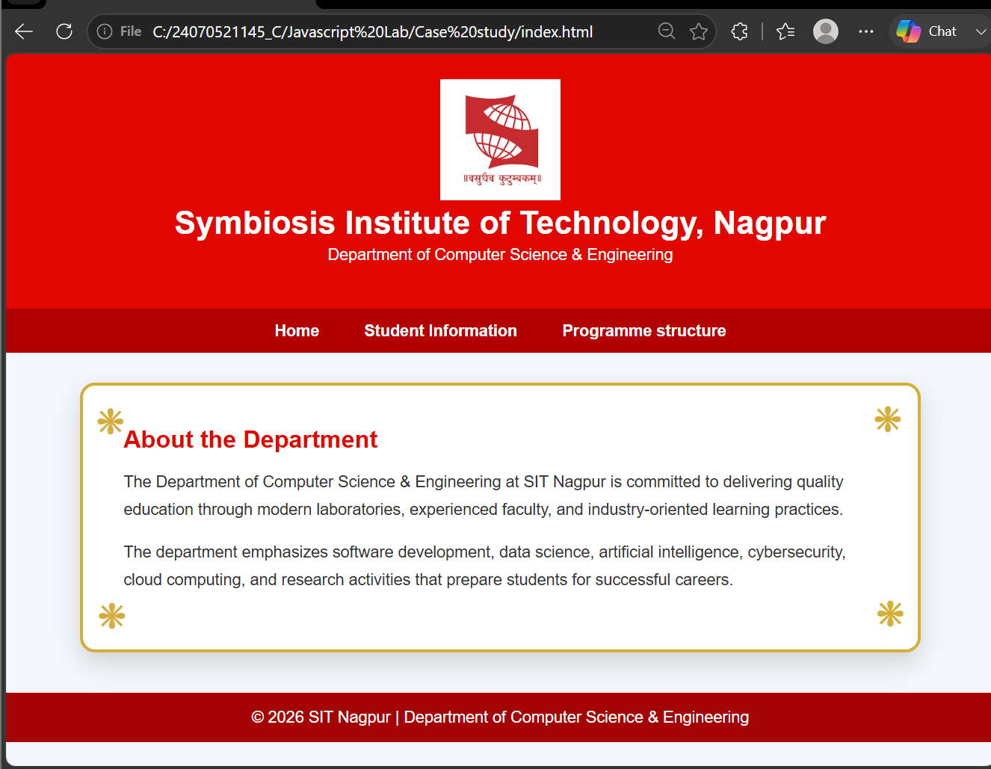

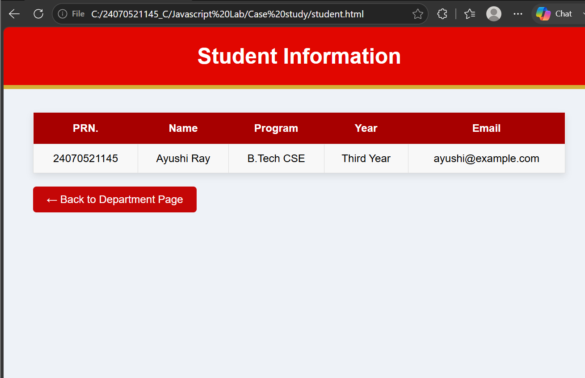

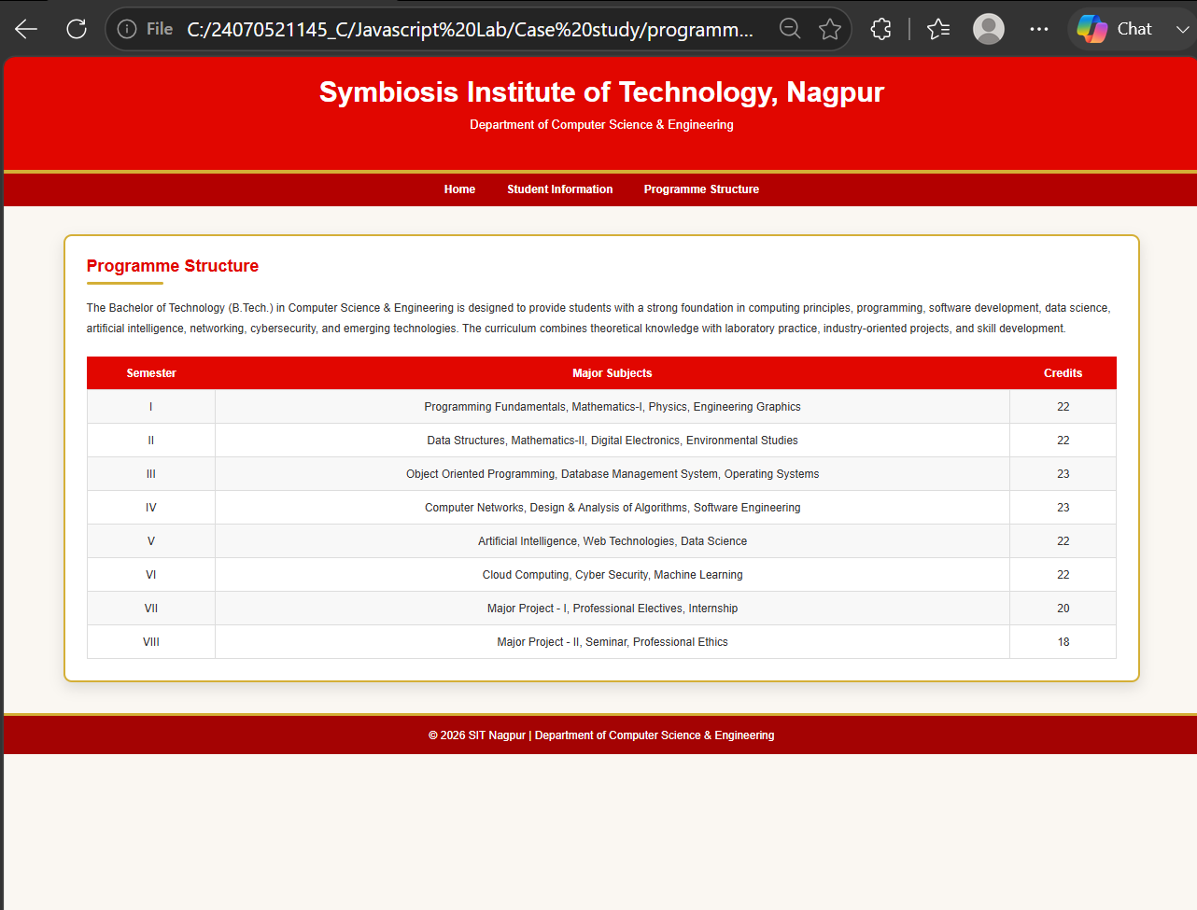

Result:
A responsive college department website was successfully developed using HTML, CSS, and JavaScript. The webpages were interconnected through hyperlinks for seamless navigation, and the JavaScript program successfully displayed the "Welcome to SIT Nagpur" alert message when the homepage was loaded. The website provided a structured, visually appealing, and interactive user interface.

